Name:__________________________________________ Score:_____________________
ECE 2036 Test II
Open book and notes, PCs and tablets allowed, but no Internet Access and C++ code cannot be run on a PC

- (10%) Assuming the short C/C++ code segment below compiles and runs, what does it output?
string str(" ECE 2036 ");
string mystr;
str = str + "Test II Fall 2014";
mystr = str.substr(7,8);
cout <<mystr <<dec<<str[5]<<mystr.length()<<hex<< str.find("1");
cout.put(0x42);
cout << endl;

Output: ______36 Test 2819B_________________________________(Note: make sure any spaces are apparent in the answer )
- (6%) What does the following code print out?
#include <iostream>
using namespace std;
int main() {
try {
try {
cout << "Start try block" << endl;
throw 2031;
cout << "End try block" << endl;
throw 2035;
}
catch (int a) { cout << "Error number:" << a << endl; throw a;}
throw 13;
}
catch (int a) { cout << "Fatal Error: " << a; }
cout << endl;
}
Start try block
Error number: 2031
Fatal Error: 2031

- (4%) The C++ ver 11 _____array___________ STL container is the most efficient choice when a random access array is needed, size can only be determined at runtime, and size does not change after the initial allocation call.

- (6%) Write a C/C++ template definition that automatically generates a function called “Biggest” that returns the larger of two values of the same type (i.e., for integers Biggest(5, 3) returns 5, or for doubles Biggest(3.0, 5.0) returns 5.0). You can assume that the “>” operator is defined (i.e, overloaded, if needed) for any type that is used with the template. Use pass by value for arguments. Include a sample function call for two ints x and y.

template <class T>
T Biggest( T a, T b)
{
if (a>b) return a;
else return b;
}
//sample call: int w = Biggest(x,y);
- (10%) On mbed, what two major C++ Object Oriented features made it possible for the uLCD.printf() function to work for the mbed color uLCD even though printf() is not found anywhere in the uLCD class code? (Include the two common terms used for these C++ features in your answer)

Inheritance: printf() is defined in the stream base class used by the uLCDclass

Polymorphism: The virtual function _putc is used by printf() to send a character to the I/O device (LCD). The uLCD class supplies this virtual function for sending the character to the uLCD

- (10%) Write a new “polar” class for a complex number that is stored in polar coordinates (i.e., a magnitude and an angle in degrees). Both internal values in the class should be type double using private (and no dynamic allocation). Include the extra code needed so that “cout<<mypolar;” where mypolar is a polar object would print the value in the format “magnitude@angle”. No member functions are needed other than a constructor that takes two type double arguments (i.e., magnitude and angle) to initialize data in a polar object.

class polar {
friend std::ostream &operator<<(std::ostream &, const polar &);
public:
polar(double m, double a): mag(m), ang(a){}
//for problem 7: polar operator*(const polar &rhs);
private:
double mag;
double ang;
};
ostream &operator<<(ostream &output, const polar &rhs){
output<<rhs.mag<<"@"<<rhs.ang;
return output;
}

- (10%) Write the additional code segment needed to be added so that a C++ statement like “mypolar1 = mypolar2 * mypolar3;” would work in the new polar class as expected (i.e., magnitudes are multiplied and angles are added). Assume the new function prototype needed for this code is already added to the polar class above and put the remaining code needed outside of the class definition in the space below.

polar polar::operator* (const polar &rhs){
return polar(mag*rhs.mag, ang+rhs.ang);
}
- (20%) Write the output in the space below that is produced by the Class constructor, destructor and operator overloading example C/C++ code provided with the test. You may have extra spaces in the table below. Recall that most compilers also use the copy constructor to make a new copy of the object whenever pass by value is used (instead of a pass by reference). Assume this also happens whenever a function returns a value that was previously setup as a local variable. Note: There may be extra lines in the table provided below.

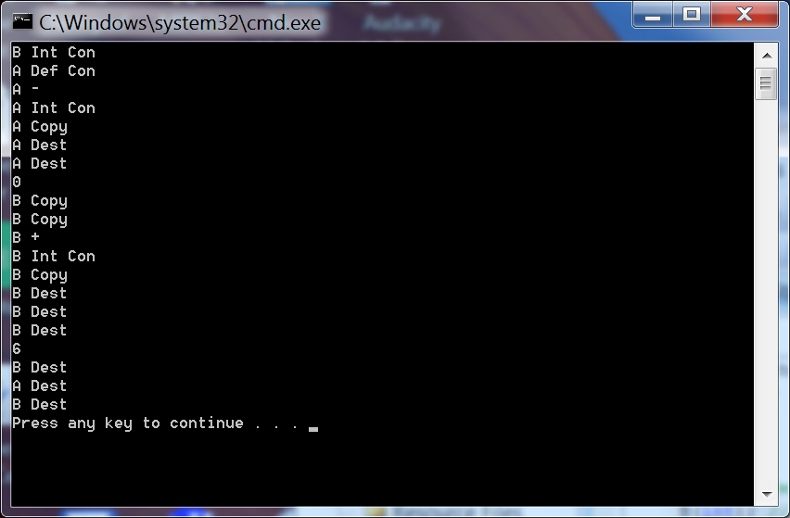

- (24%) Write the output in the space below that is produced by the Inheritance and Polymorphism example C/C++ code provided with the test. You may have extra spaces in the table below.

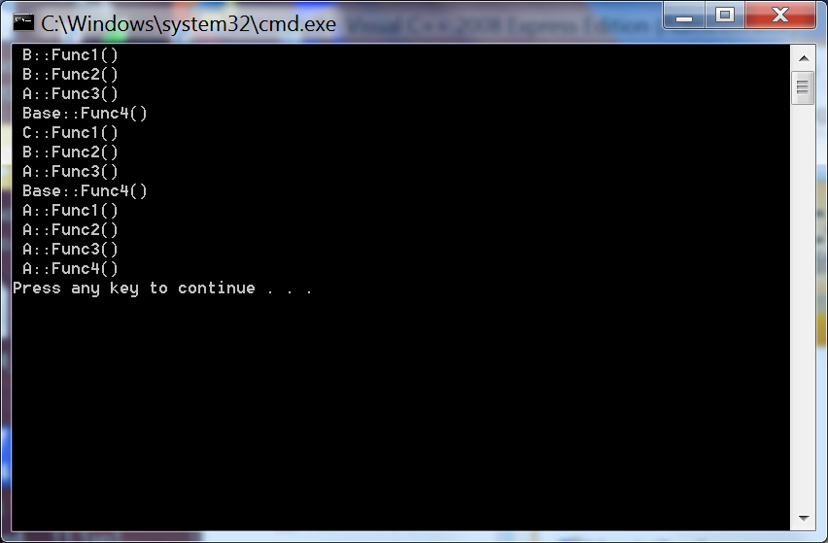

// Problem 8: C++ Code - Class Constructors, Destructors and Operator Overloading
#include <iostream>
using namespace std;
class A{
public:
A(); // Default constructor
A(int); // int Constructor
A(const A&); // Copy constructor
~A(); // Destructor
A operator-(const A& rhs) const;
public:
int x; // Single data member
};
A::A(): x(1){ cout<<"A Def Con"<<endl; };
A::A(int x): x(x){ cout<<"A Int Con"<<endl; };
A::~A(){ cout<<"A Dest"<<endl; };
A::A(const A &a){
x=a.x;
cout<<"A Copy"<<endl;
};
A A::operator-(const A& rhs) const
{
cout<<"A -"<<endl;
A r(x - rhs.x);
return r;
}
class B{
public:
B(); // Default Constructor
B(int); // int Constructor
B(const B&); // Copy constructor
~B(); // Destructor
B operator+(B rhs) const;
void print() { cout << x << endl;}
private:
int x; // Single data member
};
B::B(): x(1){ cout<< "B Def Con"<<endl;};
B::B(int x): x(x){ cout<< "B Int Con"<<endl;};
B::~B(){ cout<< "B Dest"<<endl;};
B::B(const B &b){
x=b.x;
cout<<"B Copy"<<endl;
};
B B::operator+(B rhs) const {
cout<< "B +"<<endl;
B r(x + rhs.x);
return r;
}
int main()
{
B b(3);
A a;
a = a - a;
cout << a.x << endl;
B c(b);
b = b + c;
b.print();
}
// Problem 9 : Inheritance and Polymorphism Example C++ Code
//
#include "stdafx.h"
#include <iostream>
using namespace std;
class Base
{ // Define a base class
public:
virtual void Func1() = 0;
virtual void Func2();
virtual void Func3();
void Func4();
};
class A : public Base
{ // Class A derives from Base
public:
virtual void Func1();
virtual void Func2();
virtual void Func3();
virtual void Func4();
};
class B : public A
{// Class B derives from A
public:
virtual void Func1();
void Func2();
};
class C : public B
{ // Class C derives from B
public:
virtual void Func1();
virtual void Func4();
};
// Base Class Methods
void Base::Func2(){ cout << " Base::Func2()" << endl;}
void Base::Func3(){ cout << " Base::Func3()" << endl;}
void Base::Func4(){ cout << " Base::Func4()" << endl;}
// Class A Methods
void A::Func1() { cout << " A::Func1()" << endl; }
void A::Func2() { cout << " A::Func2()" << endl; }
void A::Func3() { cout << " A::Func3()" << endl; }
void A::Func4() { cout << " A::Func4()" << endl; }
// Class B Methods
void B::Func1() { cout << " B::Func1()" << endl; }
void B::Func2() { cout << " B::Func2()" << endl; }
// Class C Methods
void C::Func1() { cout << " C::Func1()" << endl; }
void C::Func4() { cout << " C::Func4()" << endl; }
void TestFuncVal(A x){
x.Func1();
x.Func2();
x.Func3();
x.Func4();
}
void TestFuncRef(Base& x){
x.Func1();
x.Func2();
x.Func3();
x.Func4();
}
int main(){
B b;
C c;
TestFuncRef(b);
TestFuncRef(c);
TestFuncVal(c);
}

