Name:__________________________________________ Score:_____________________
ECE 2036 Test II
Open book and notes, PCs and tablets allowed, but no Internet Access and code cannot be run on a PC

- (10%) Assuming the short C/C++ code segment below compiles, what is output?
string str("Hello C/C++ String World");
string mystr;
mystr=str.substr(6,6);
cout << mystr << hex << str.length() << str[6] << mystr.length();
cout.put(65).put(66);
cout << endl;

Output: C/C++ 18C6AB

- (5%) What happens if an exception is thrown outside of a try block?

Terminate is called, the program stops execution and a default error message may be displayed.

- (15%) Write a C/C++ template definition that automatically generates a function called “smaller” that returns the smaller of two values of the same type (i.e., small(2, 3) returns 2 or small(3.0, 2.0) returns 2.0). You can assume that the “<” operator is defined for any type that is used with the template.

template <class myType>
myType smaller (myType a, myType b) {
if (a<b) return a;
else return b;
}

- (5%) C uses the two functions ___malloc____ and ____free_____ for dynamic memory

management, and C++ uses _____new____ and ____delete_______ . If these do not match up during program execution so that any dynamically allocated memory is returned when no longer

needed, a type of error occurs that is called a _memory___ ___leak_____.

- (10%) If a new class definition needs dynamic memory allocation, the user also typically needs to

provide (i.e., not use the default) code for the classes’ ____constructor_________,

__copy______ __constructor__, and ____destructor___. It is also likely that the user

will want to overload the ____assignment or “=”________ operator (first before the other operators).

- (10%) In a class that uses dynamic memory allocation for member data, assuming “A=B;” works some special code is also needed so that a statement like “A=A;” will work properly (i.e., A and B are objects from the new class).

This is called __self____ _assignment_____________ and code to handle it is typically

placed in the __assignment_________ ____operator____________ overload.

Write a C++ statement in the space below that is typically added to solve the “A=A;” problem.

if (rhs != this){ if (rhs==this) return;
//code to copy object OR
}

- (5%) If only a pointer is passed to an object that is from a derived class that contains virtual functions, how does the program find the correct virtual function code at runtime?

Objects with a virtual function have a pointer to the object’s virtual function table. The virtual function table has a pointer to each of the object’s virtual functions.
- (20%) Write the output in the space below that is produced by the Constructor Destructor example C/C++ code provided with the test. Recall that most compilers use the copy constructor to make a new copy of the object whenever pass by value is used (instead of a pass by reference).
Assume this also includes functions that return a value.

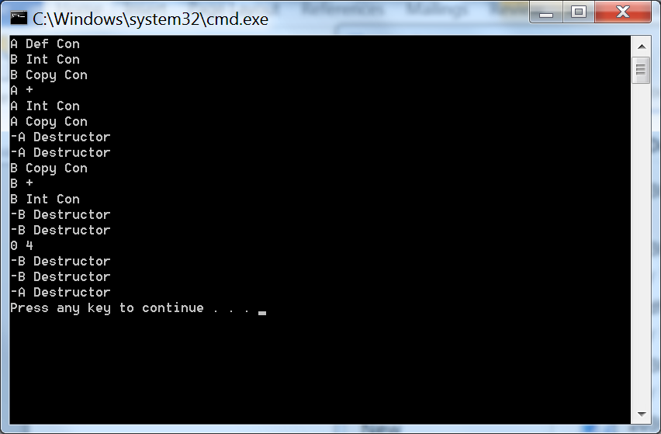
- (20%) Write the output in the space below that is produced by the Inheritance and Polymorphism example C/C++ code provided with the test.

