Details on mbed Parts Kits for ECE 2035, 2036 and 4180 Labs:

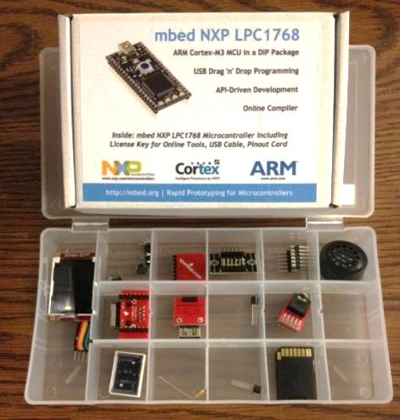

As a service to GT ECE students, we put together parts kits for ECE 2035, ECE 2036, ECE 4180 and sell them at deep discounts to you over what you would pay by purchasing the items yourself (we get educational bulk discounts and pay for only one shipping cost for all the parts). Everyone in 2035 and 2036 should purchase his/her own new parts kits. Parts kits are optional for 4180, but they will allow you to work on the majority of labs at home if you also purchase the optional 4180 robot & sensor add-on kit.

The kits are available online at the Georgia Tech Shopping Mall, under the category of “ECE Classroom Kits”: https://epay.gatech.edu/C20793_ustores/web/. This site will be open only through the first week of classes, so PURCHASES MUST BE MADE BY SATURDAY 8/23/14. When ordering the kit, it will ask you for your section number. If you are registered for ECE2035A, then enter A in that field.

If you have an older kit that contains the old style of LCD display (text only monochrome), then you should purchase the new LCD display and new speaker separately. The new kits come with these parts already, so do not buy them separately. IMPORTANT: You will also need a large breadboard, larger than the one in the GT Shopping Mall. The one used for ECE2031 is fine. If you have not yet bought one, then you might be able to buy one from HKN, who sells parts kits for ECE labs early in the term (emails details on the day this occurs should show up a few days after the term starts).

The delivery pick up times will be posted in the payment confirmation email sent to you.

If you miss either the purchase date or the pick-up dates or the HKN breadboard sale day, you will need to order the parts on your own through an electronics vendor, such as Digikey or Sparkfun. If you have paid for the kit and do not pick it up, we will refund your money. The parts kit list for directly ordering parts is available on the web and soldering will also be required on many of the sensor breakout boards.

